Power BI – Sales Performance Dashboard
Calculated Columns, DAX Measures, Visualizations, Slicers,
Performance Analyzer and Business Insights
Documentation of report development, performance review and business analysis.

1. Overview
This document covers the Power BI Sales Performance report work: four calculated columns, ten DAX measures, four visualizations, two slicers, a Performance Analyzer check, and five business insights from the data.
The report uses four tables: Sales, Customers, Dates and Products. The Sales table has 4,531 rows. The main dashboard (Sales Performance page) shows Total Revenue 59.45M, Total Orders 3K, Total Customers 252 and Average Order Value 22.86K.
The work is shown across three report pages: the Sales Performance dashboard, Page 1 with the four task visualizations and the City and Date slicers, and Page 2 with the analysis visuals used for the insights in Section 7.

2. Calculated Columns
Four calculated columns were added to the Sales table to support cost, profit, revenue classification and order-size analysis. Each column was validated in Table View against the underlying sales records.
Calculated column | Definition and purpose
Line Cost | Represents the total cost of an individual sales line, derived from the unit cost and the quantity ordered. It provides the cost basis for profitability analysis at line level.
Line Profit | Represents the profit earned on an individual sales line, after deducting line cost from line revenue. It enables profit to be reviewed by product, category and order.
Revenue Band | Classifies each sales line by revenue value to support value-based segmentation: lines are grouped as High, Medium or Low, with High representing revenue of 50,000 or more and Medium representing revenue from 10,000 to below 50,000.
Lines in Order | Records the number of product lines contained in the order to which each sales line belongs. It supports analysis of basket size and its relationship to order value.

Validation in Table View confirmed that Revenue Band returns three distinct classifications and Lines in Order returns four distinct values across the 4,531 rows of the Sales table, consistent with the structure of the source data.
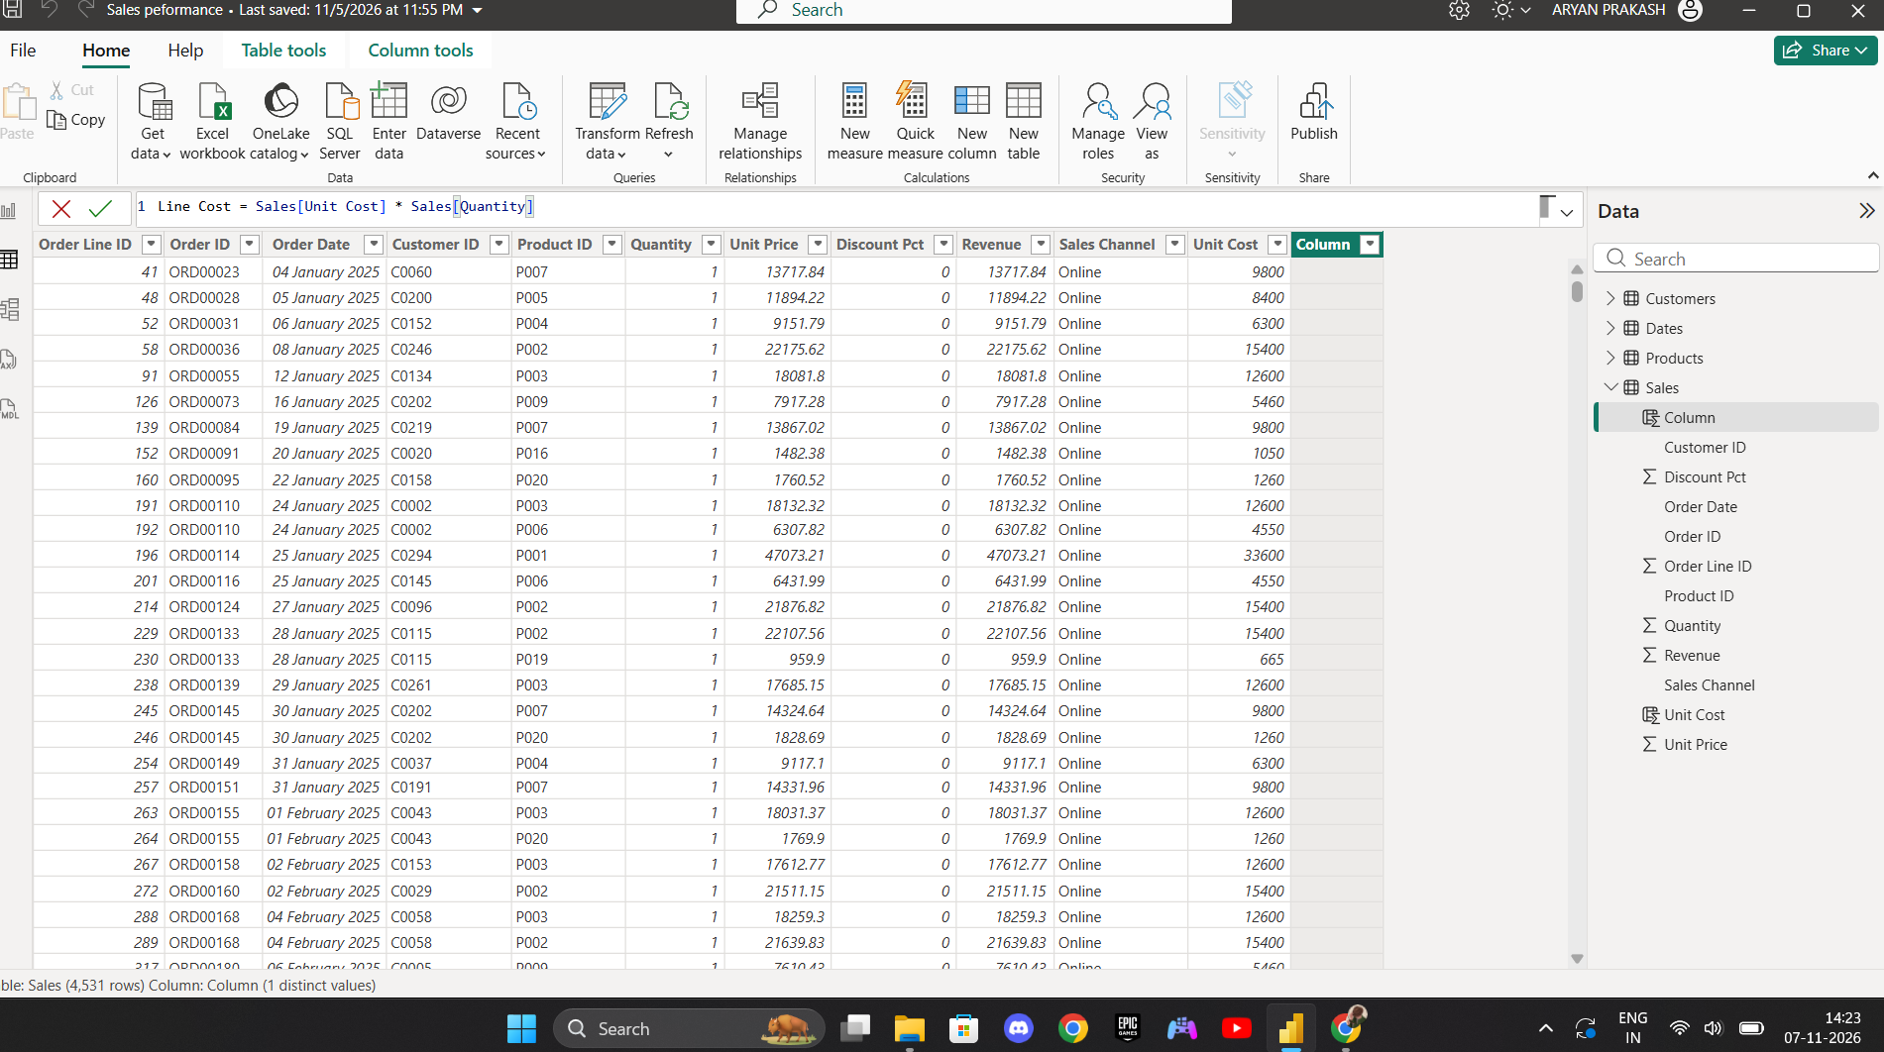
Figure 1: Table View – creating the Line Cost column in the Sales table.
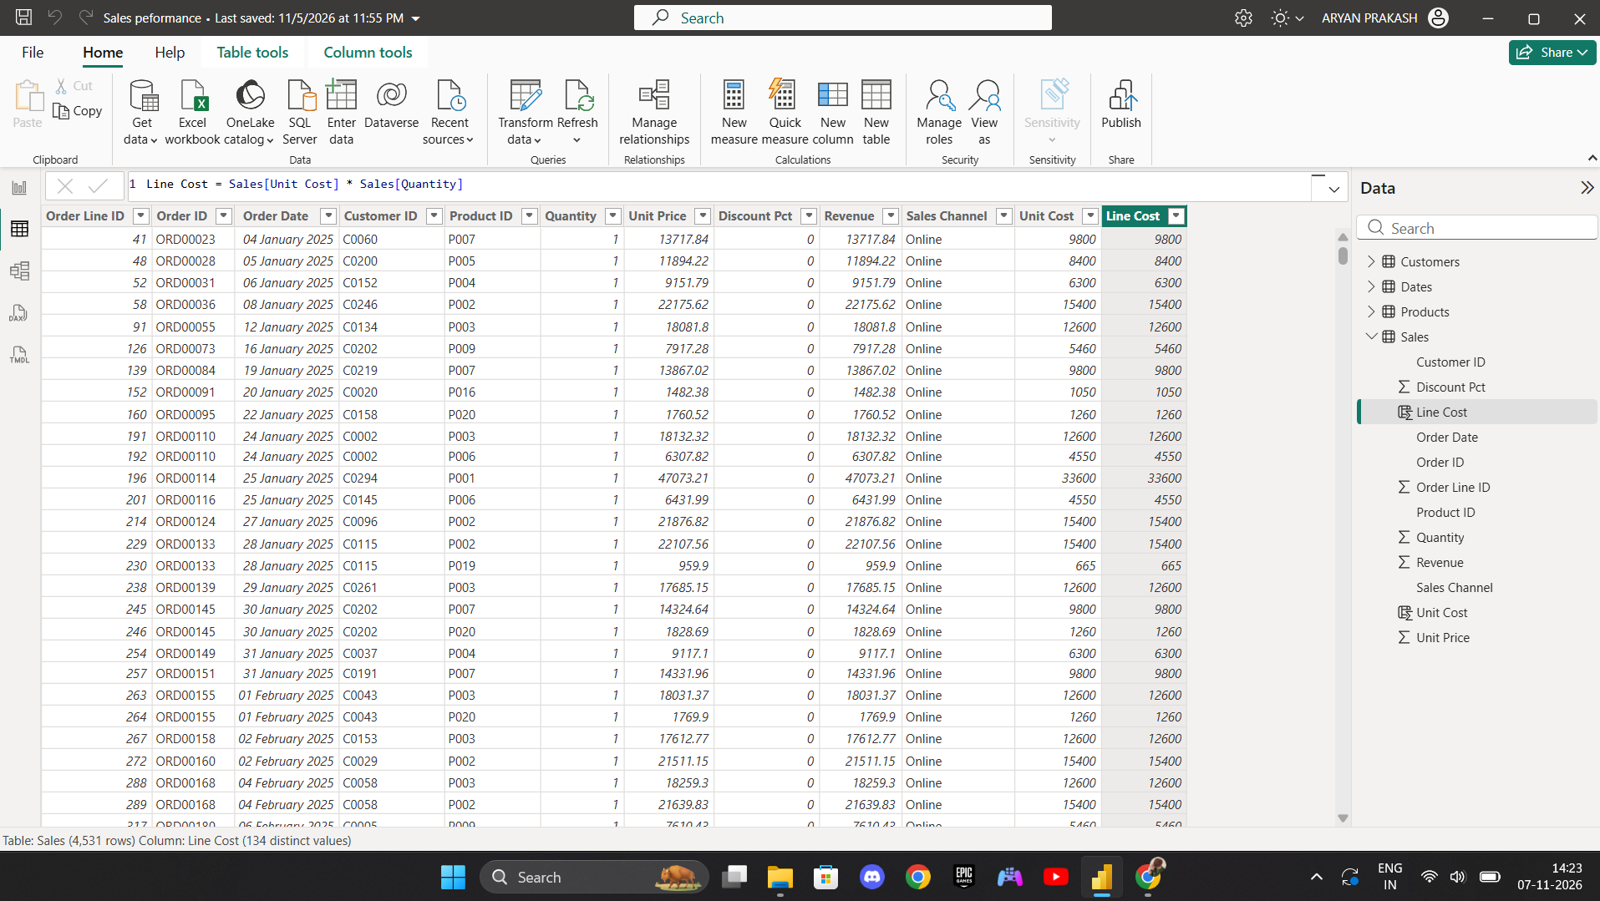
Figure 2: Table View – Line Cost column created and verified (134 distinct values).
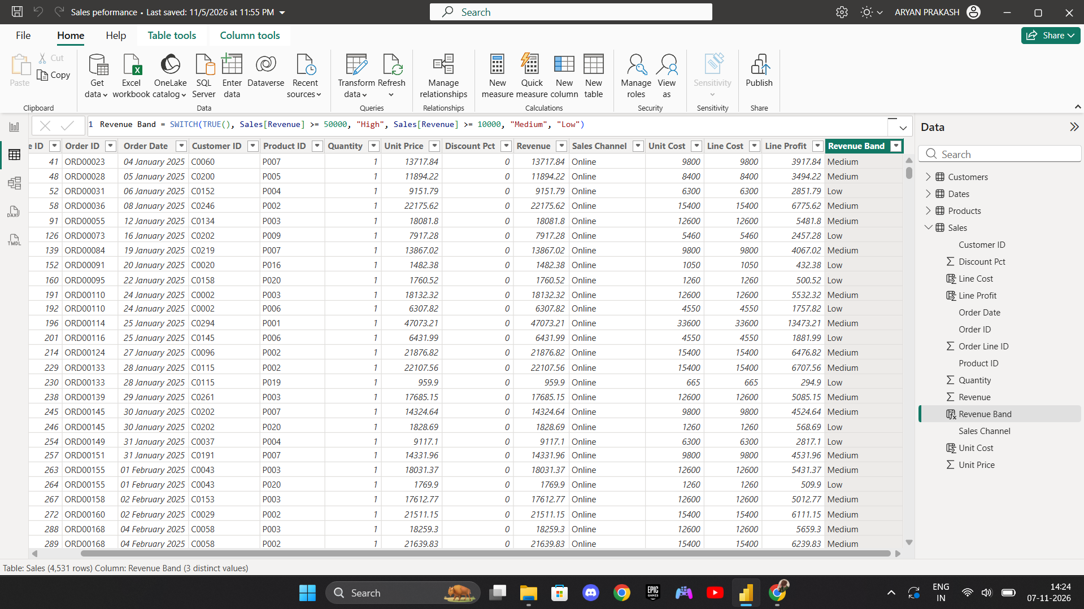
Figure 3: Table View – Revenue Band column with High, Medium and Low values.
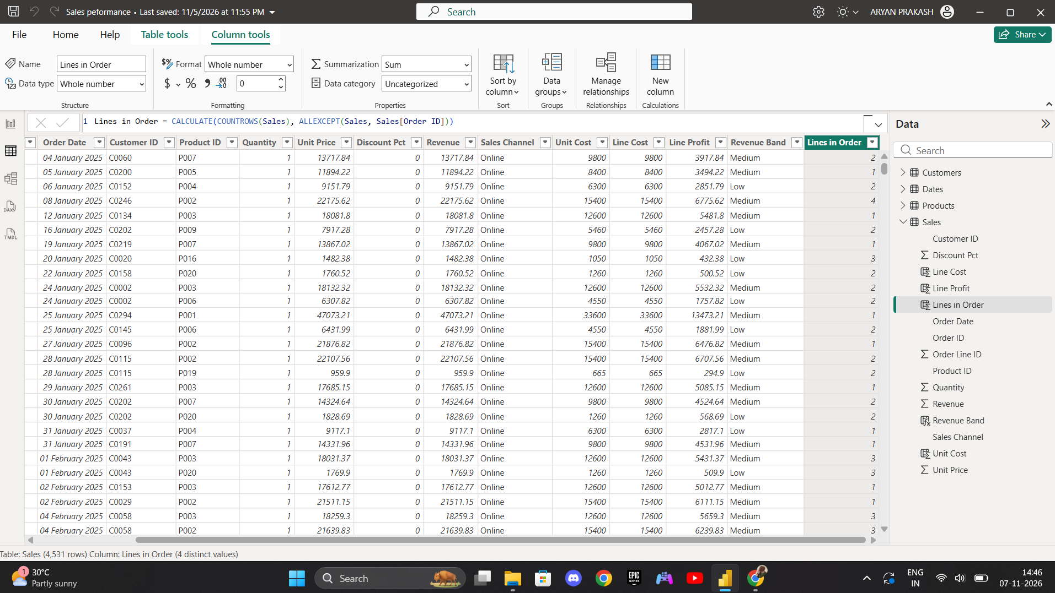
Figure 4: Table View – Lines in Order column, showing the number of lines in each order.

3. DAX Measures
The following ten measures were created using DAX:
- Total Orders
- Total Customers
- Total Sales
- Gross Profit
- Average Order Value
- Sales Target
- Total Cost
- Target Achievement
- Target Status
- Profit Margin
The measures are listed in the Data pane in the screenshots, along with supporting measures such as Total Revenue, Discount Amount, Orders per Customer, Revenue MoM % and Revenue per Customer.
Target Status classifies performance against target into three categories based on Target Achievement: Target Met where the target is fully achieved, Near Target where achievement reaches at least 90%, and Below Target in all other cases. This classification provides a clear, consistent status indicator for monthly and quarterly reporting.
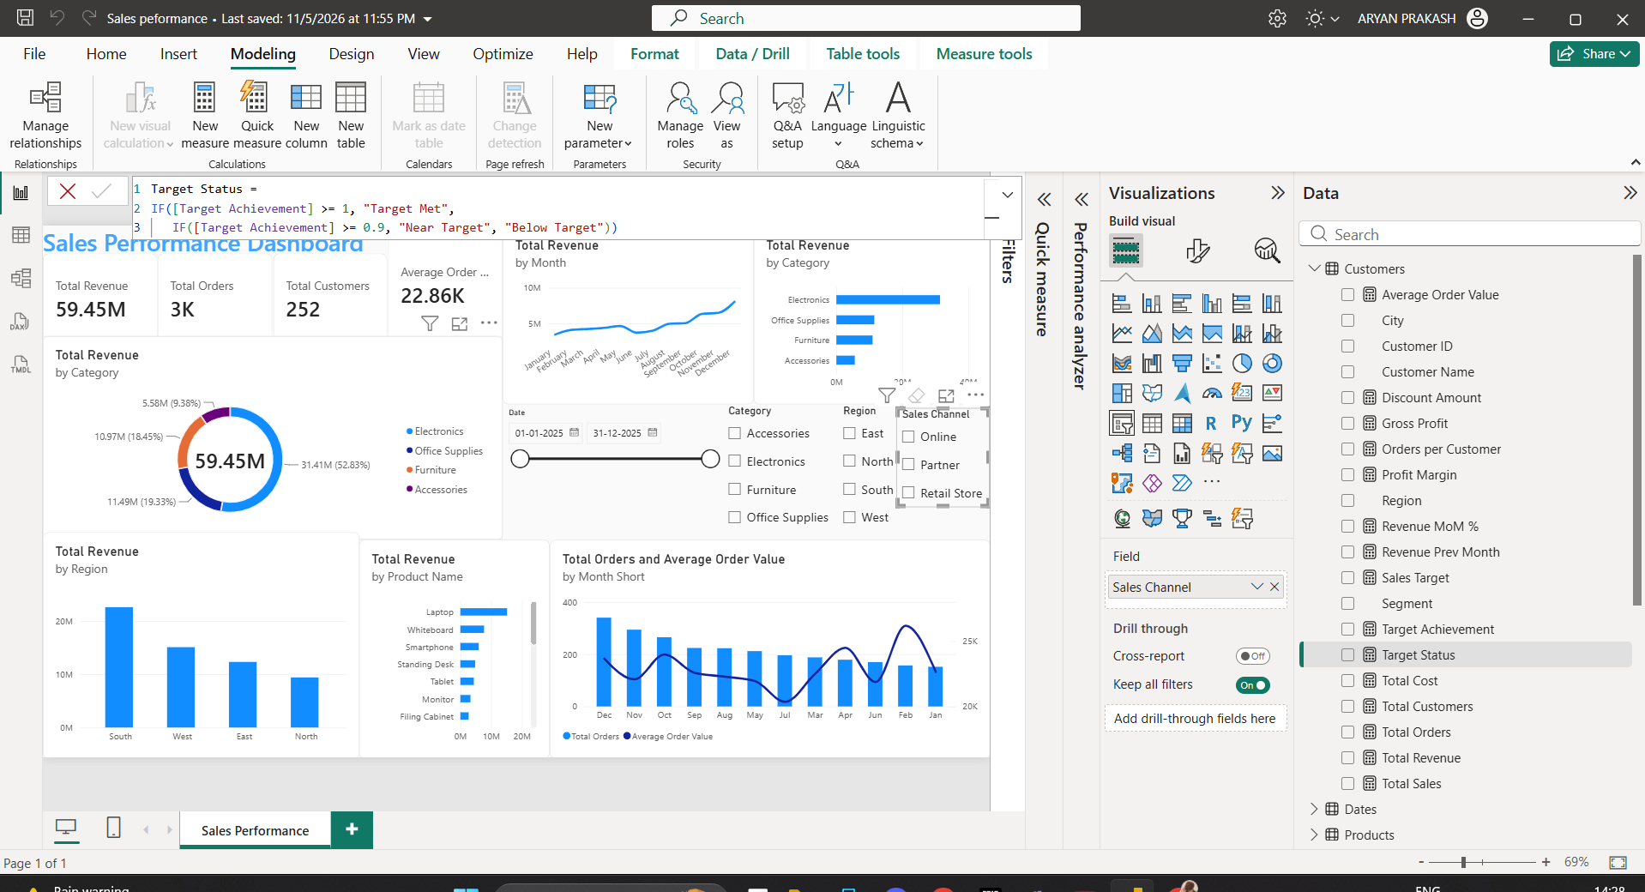
Figure 5: Report View – Target Status measure, with the DAX measures listed in the Data pane and the dashboard KPIs on the left.

4. Visualizations
The following charts were created in Report View on Page 1:
- Bar chart: Sum of Quantity by City and Category – compares the category mix across cities. Kolkata and Bengaluru have the highest quantities, and Office Supplies is the largest part in every city.
- Column chart: Total Sales by Product Name – compares sales across products. Laptop is the highest, followed by Whiteboard and Smartphone.
- Line chart: Total Sales by Month – shows how sales change over time, rising through the year with a dip in June and the highest value in December.
- Pie chart: Total Sales by Category – shows each category's share of total sales: Electronics 31.41M (52.83%), Office Supplies 11.49M (19.33%), Furniture 10.97M (18.45%) and Accessories 5.58M (9.38%).
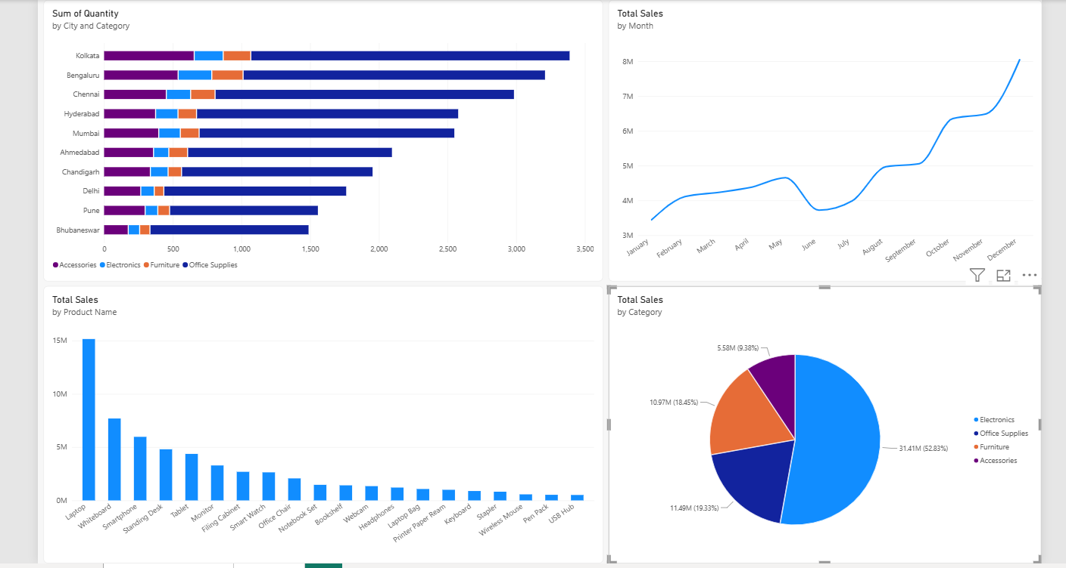
Figure 6: Report View (Page 1) – the four visualizations: quantity by City and Category, Total Sales by Month, Total Sales by Product Name, and Total Sales by Category.
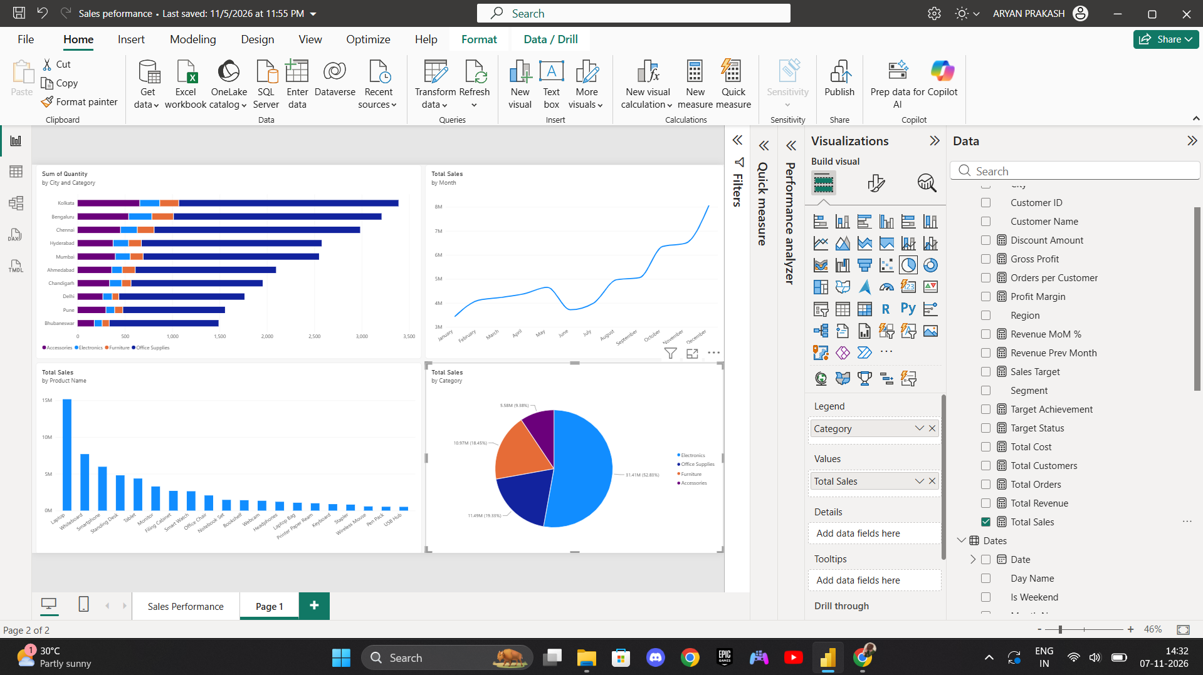
Figure 7: Report View (Page 1) – the same four visualizations with the Visualizations and Data panes open, showing Total Sales by Category selected.

5. Slicers
Two interactive slicers were added to Page 1:
- City slicer – filters the report by city (Ahmedabad, Bengaluru, Bhubaneswar, Chandigarh, Chennai, Delhi, Hyderabad, Kolkata, Mumbai and Pune).
- Date slicer – filters the report by the selected date range.
All charts respond to the slicer selections. In the screenshot below, Delhi is selected in the City slicer and the Date slicer is set from 01-01-2025 to 14-08-2025, so every chart on the page shows only that selection.
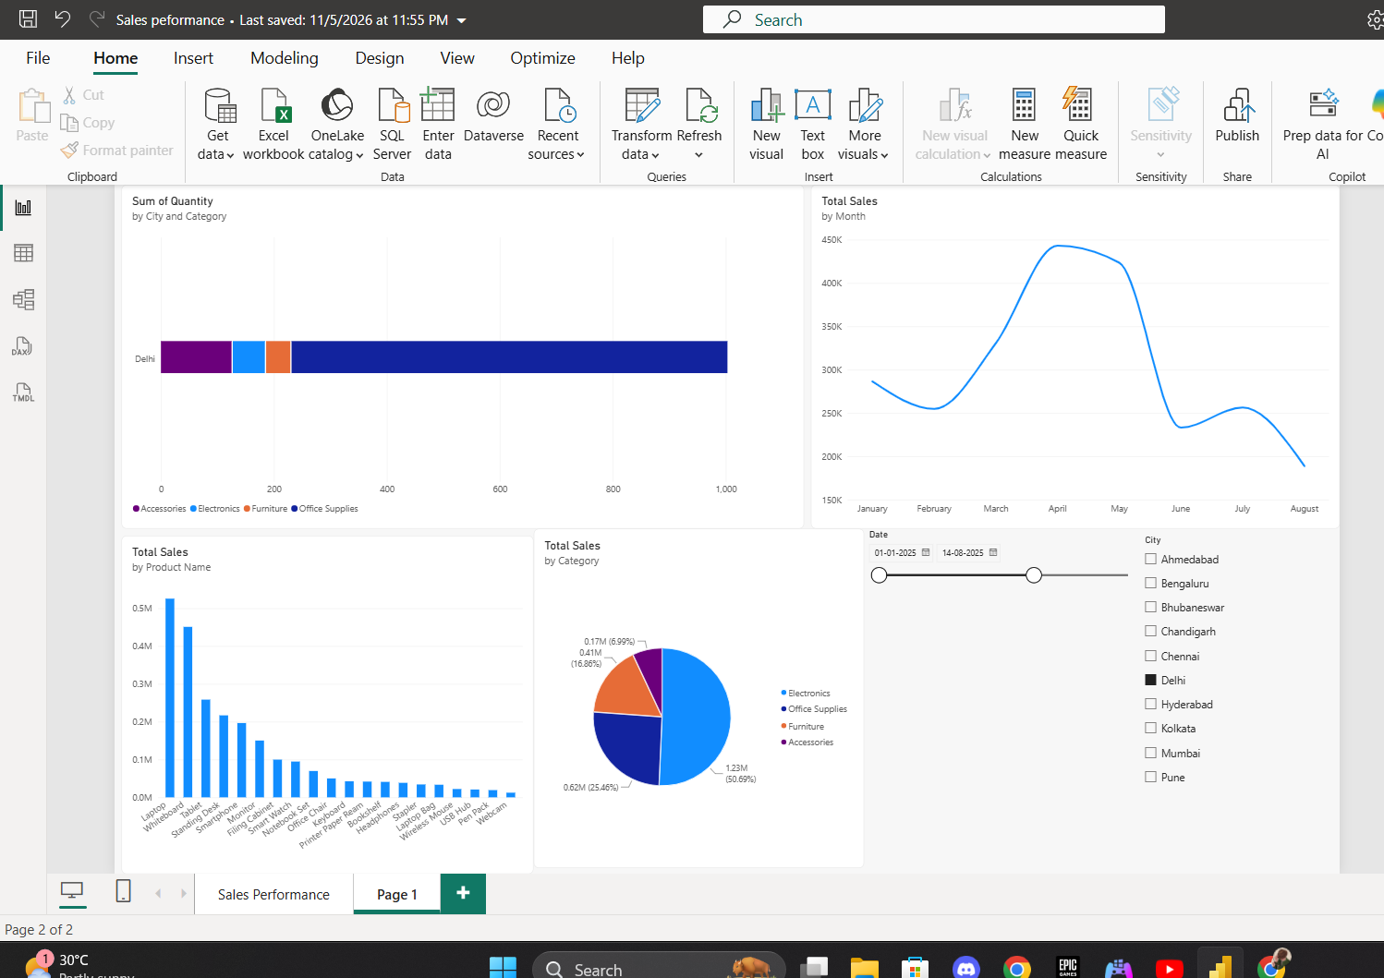
Figure 8: Report View (Page 1) – City slicer set to Delhi and Date slicer set to 01-01-2025 to 14-08-2025, with all four charts filtered.

6. Performance Analyzer
Performance was checked on the Sales Performance dashboard page:
- The Optimize tab was opened and Performance Analyzer was selected.
- Recording was started to monitor visual performance.
- All report visuals were refreshed (Refresh visuals).
- The time taken by each visual to load and render was noted from the Duration (ms) column.
- The slower visuals were identified from the same list.
Results from the recording started on 07-11-2026 at 14:12:54:
- All visuals loaded in under about 420 ms, so no visual is very slow.
- The Total Revenue card visuals took the longest, at about 396 to 418 ms.
- Total Revenue by Category took 381 to 386 ms, the slicers 377 to 379 ms, and Total Revenue by Region, by Product Name and the Orders and Average Order Value chart 375 to 377 ms.
- Text boxes were the fastest, at 164 to 169 ms.
The check was repeated after changing a slicer. With the dashboard filtered, the same visuals were timed again, which confirms the visuals still respond and load after a slicer change. The Products table used by the report is in Import storage mode, with data refreshed on 11/5/2026 at 11:05:57 PM.
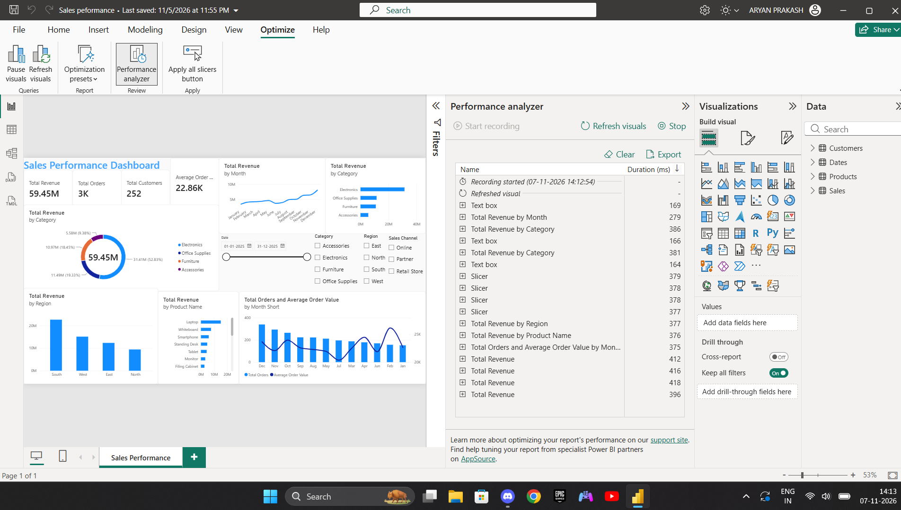
Figure 9: Optimize tab – Performance Analyzer recording for the full Sales Performance Dashboard, with the duration of each visual.
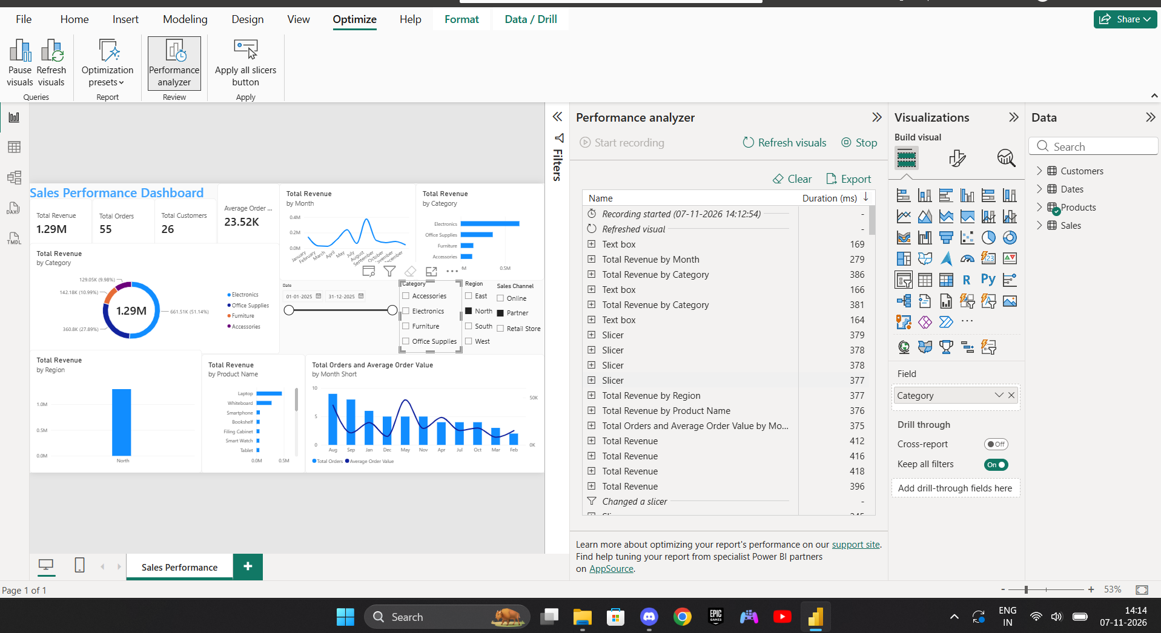
Figure 10: Performance Analyzer – dashboard filtered to North region (Total Revenue 1.29M, 55 orders, 26 customers), with visual durations and the 'Changed a slicer' entry.
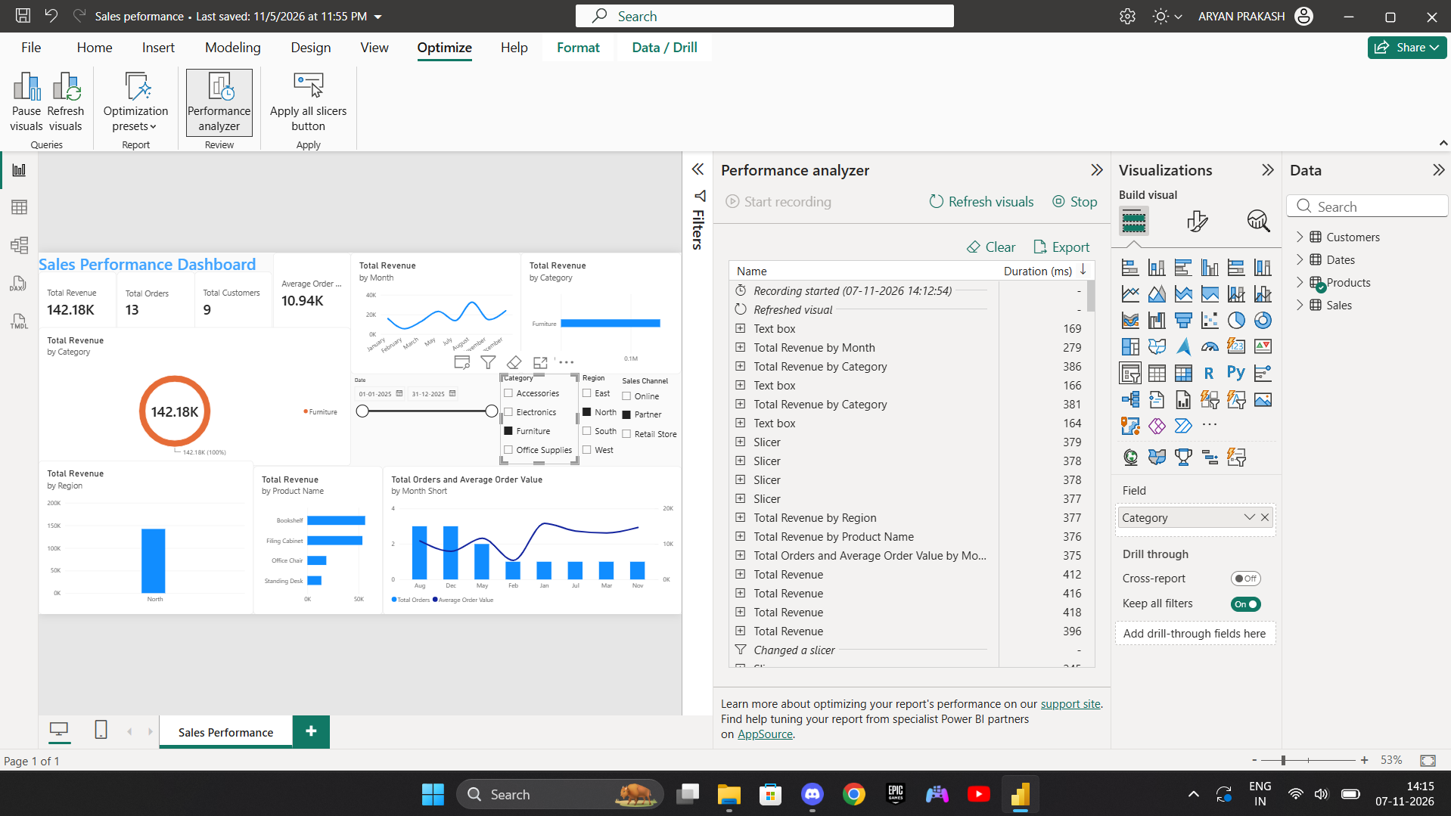
Figure 11: Performance Analyzer – dashboard filtered to Furniture and North / Partner (Total Revenue 142.18K, 13 orders, 9 customers).
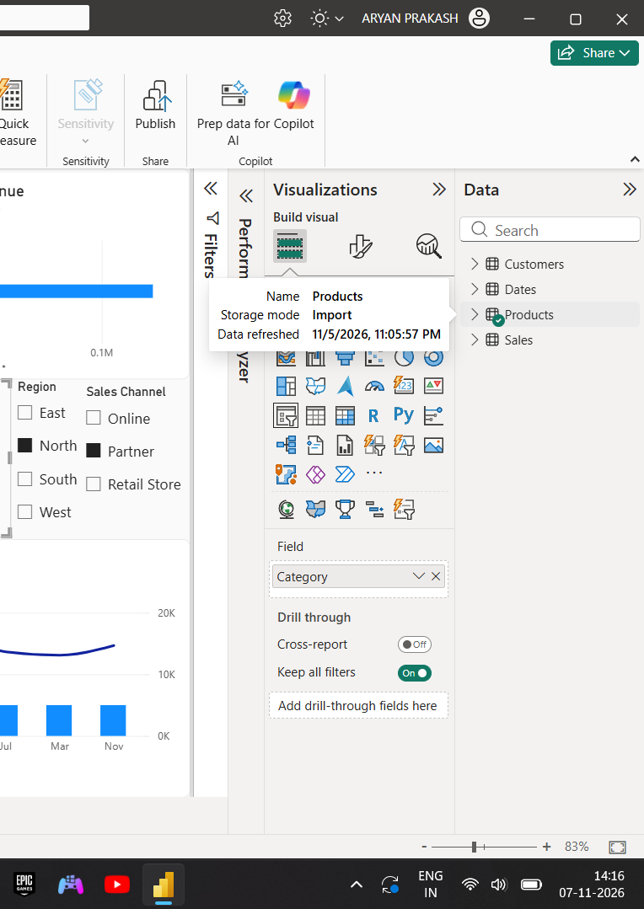
Figure 12: Data pane – Products table details: Storage mode Import, data refreshed 11/5/2026, 11:05:57 PM.

7. Business Insights
The dataset was analysed for five key insights, covering sales performance, customer trends, order patterns, profitability, and sales target achievement. Each insight has the finding, what it means, a recommendation, and the Power BI visual that supports it.
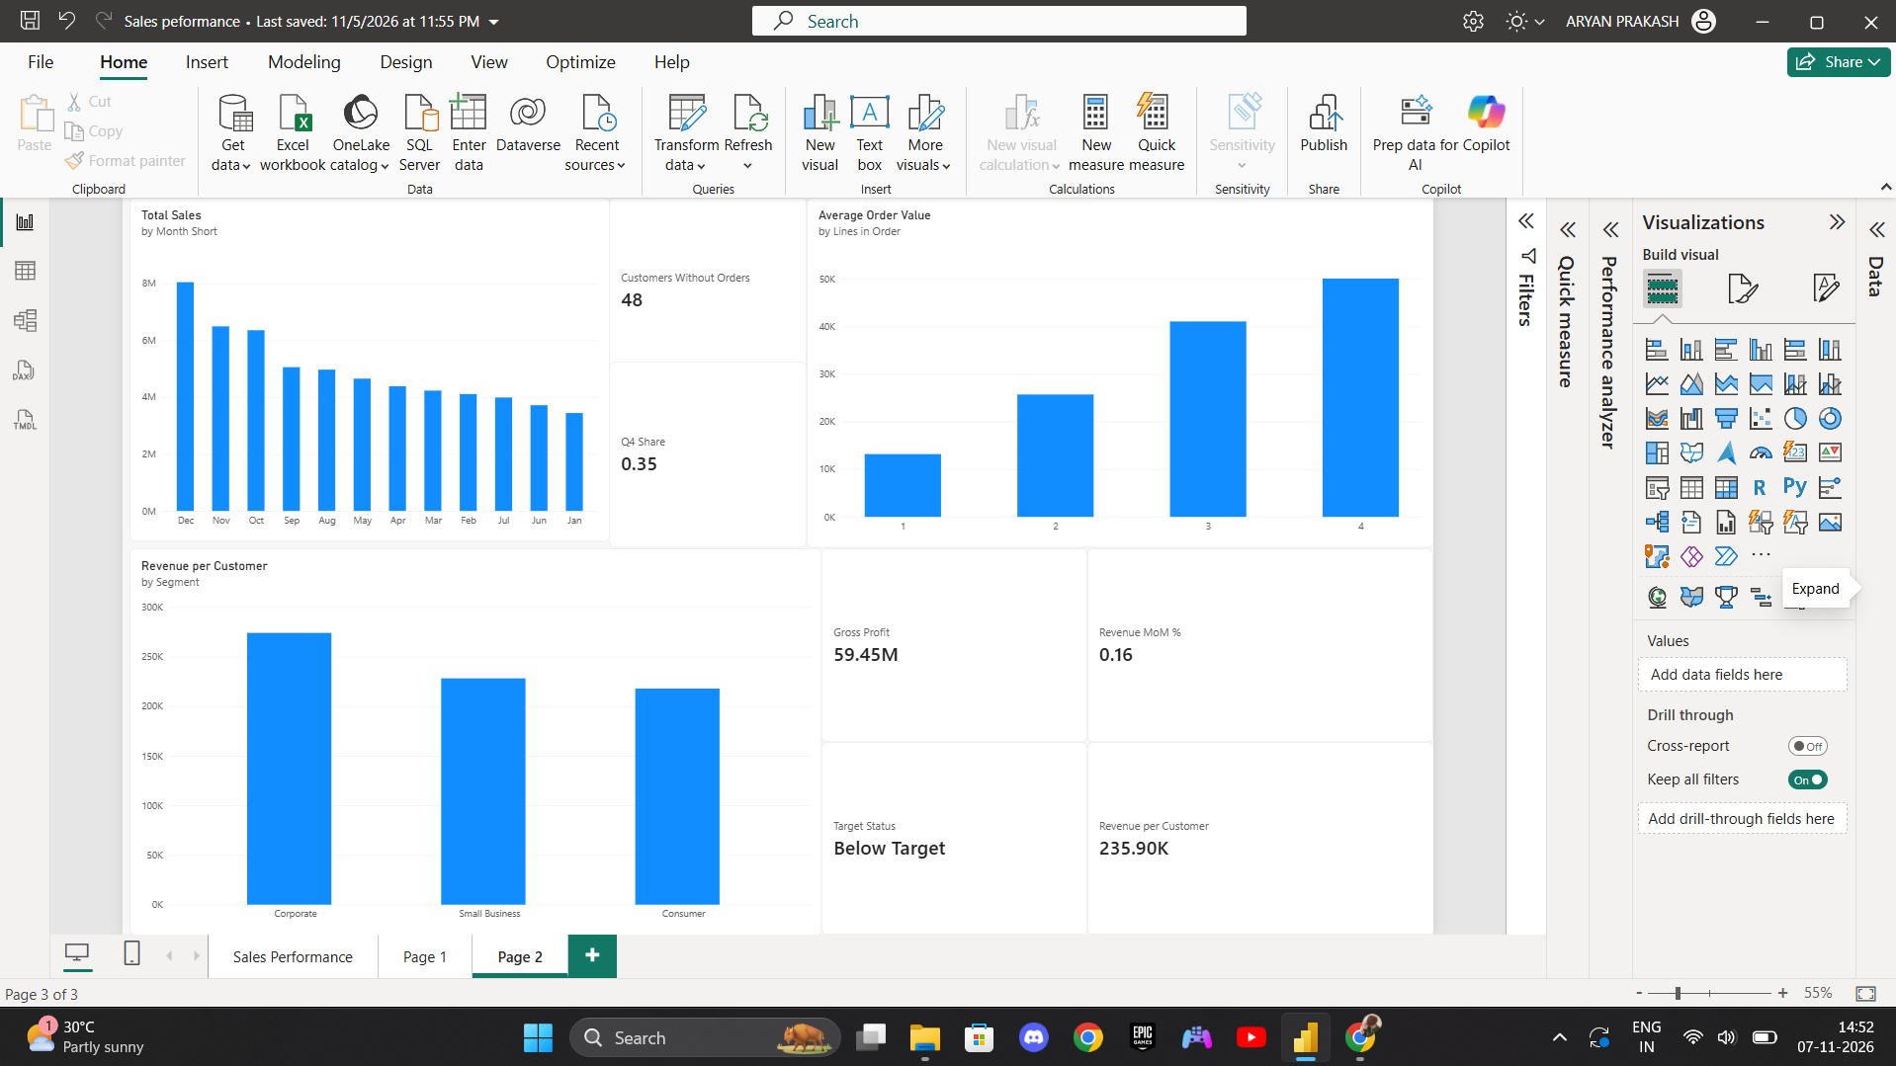
Figure 13: Report View (Page 2) – analysis visuals used for the insights: Total Sales by Month, Average Order Value by Lines in Order, Revenue per Customer by Segment, Customers Without Orders (48) and Q4 Share (0.35).

Insight 1: Sales performance – Revenue is strongly seasonal and Electronics-led
Insight: Monthly revenue rises from ₹3.44M in January to ₹8.05M in December, about 2.3 times higher. Q4 brings in 35.1% of annual sales, with a dip in June (−20.1% against May). Electronics alone is 52.8% of revenue (₹31.4M).
Interpretation: Performance rests on the festive-season peak and on a single category. The quiet months (January, June) leave capacity unused, and a slowdown in Electronics would hit the whole business.
Recommendation: Plan stock and staffing around Q4, run targeted promotions in January and June to even out demand, and grow Furniture, Office Supplies and Accessories to reduce reliance on Electronics.
Power BI evidence: Column chart with Month Short on the axis and Total Sales as values. Also show the Q4 Share card and the category donut.

Insight 2: Customer trends – Revenue is concentrated in few customers, and many registered customers are inactive
Insight: 252 of 300 customers placed orders, so 48 never did. The top 10 customers (about 4% of active customers) generate 18.8% of revenue. Corporate customers spend the most per customer (₹274K, against ₹228K for Small Business and ₹218K for Consumer). North has the lowest revenue per customer at ₹192K, against ₹262K in East.
Interpretation: A handful of accounts carry a lot of revenue, which is a retention risk. There is an untapped base of 48 inactive customers, Corporate is the most valuable segment per head, and North is the weakest region.
Recommendation: Give top customers dedicated account management or loyalty benefits, run a reactivation campaign for the inactive 48, put acquisition effort into Corporate, and review pricing and coverage in North.
Power BI evidence: Clustered column chart with Customers[Segment] and Revenue per Customer. Add cards for Customers Without Orders and Top 10 Customer Share. A bar chart of Customer Label with a Top N filter (10) on Total Sales also works.

Insight 3: Order patterns – Growth comes from more orders, and basket size drives order value
Insight: Orders per month rise from 152 in January to 340 in December, while average order value stays between ₹20,000 and ₹26,000 (about ₹22,900 overall). Half of all orders (50.3%) contain one product line and average ₹13.2K. Orders with 3 lines average ₹41.1K and those with 4 average ₹50.1K. Average order value is nearly identical across channels (₹22.7K to ₹23.2K).
Interpretation: Growth is volume-driven, not price-driven. What a customer buys, not where, sets the order value, so basket size is an under-used lever.
Recommendation: Use bundles and cross-sells, such as accessories with laptops. Add minimum-spend offers or free-delivery thresholds to move single-line orders to two lines. Judge channels by volume rather than order value.
Power BI evidence: Column chart with Lines in Order on the axis and Average Order Value as values. Add the Orders vs AOV combo chart by month.

Insight 4: Profitability – Discounts cut margin sharply
Insight: Gross profit is ₹15.66M, a 26.3% margin. Margin falls with each discount level: 30.1% at no discount, 26.4% at 5%, 22.3% at 10% and 17.6% at 15%. About 49% of revenue is sold at some discount, and total discounts come to ₹3.16M (5.0% of gross sales). Electronics delivers 53% of gross profit.
Interpretation: Nearly half of sales are discounted, and the deepest discounts earn well under two-thirds of the full-price margin. Category margins are almost identical (26.0% to 26.5%), so discount policy is the main profit lever. That near-equality comes from the single assumed cost ratio, so it should not be over-read.
Recommendation: Cap discounts at 10% unless tied to larger baskets, review margin by discount level every month, and replace the assumed cost with actual cost data for reliable category-level profitability.
Power BI evidence: Column chart with Sales[Discount Pct] on the axis (set Type to Categorical) and Profit Margin as values. Add cards for Gross Profit, Profit Margin and Discount Amount.

Insight 5: Sales target achievement – The target is met only in the final quarter
Insight: Against the ₹5M monthly target, only 4 of 12 months (September to December) reach it. The first half achieves 81.8% and the second half 116.4%. By quarter it is 78.6%, 85.0%, 93.4% and 139.3%. Full-year achievement is 99.1% (“Near Target”), carried by December at 160.9%.
Interpretation: The year-end surge hides eight under-target months. A flat monthly target does not match the seasonal pattern, and hitting the annual number depends on one quarter.
Recommendation: Phase the target by season (lower in Q1 and Q2, higher in Q4), start Q1 to Q3 initiatives to close the gap earlier, and track Target Achievement and Target Status monthly so shortfalls show up early.
Power BI evidence: Column chart with Dates[Quarter] and Target Achievement. Colour the bars with Format → Columns → Colors → fx (rules: ≥ 100% green, 90% to 99% amber, below 90% red). Add a card for Target Status, and optionally a combo of Total Sales columns against Sales Target as a line by month.

8. Summary
The expected outcome is complete:
- Four calculated columns created in the Sales table and verified in Table View: Line Cost, Line Profit, Revenue Band and Lines in Order.
- Ten DAX measures created: Total Orders, Total Customers, Total Sales, Gross Profit, Average Order Value, Sales Target, Total Cost, Target Achievement, Target Status and Profit Margin.
- Four visualizations created on Page 1: quantity by City and Category, Total Sales by Product Name, Total Sales by Month, and Total Sales by Category.
- Two interactive slicers added: City and Date, with all charts responding to the selections.
- Performance Analyzer run from the Optimize tab: all visuals loaded in under about 420 ms, with the Total Revenue cards the slowest and text boxes the fastest.
- Five business insights recorded, covering sales performance, customer trends, order patterns, profitability, and sales target achievement, each with an interpretation, a recommendation, and the Power BI visual that supports it.
Screenshots submitted with this document: Table View showing the calculated columns, and Report View showing the DAX measures, the completed visualizations, the slicers, the Performance Analyzer results, and the Page 2 analysis visuals.

